Lunisolar Year
# Source: AI Source: Provided by: [Data Path: Persons Table -> ID Column: 1, Name_En Column: Motasem Essam] -> From: [ChatGPT] on [7/17/2026]
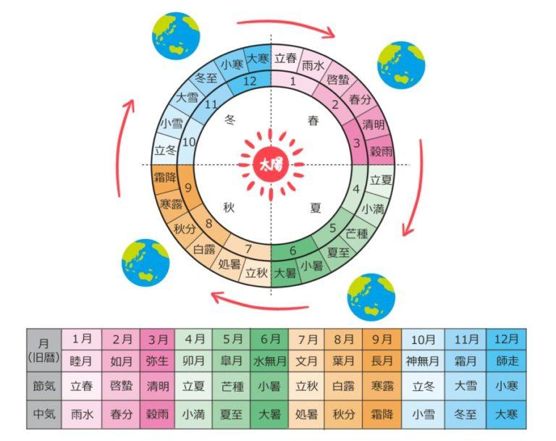
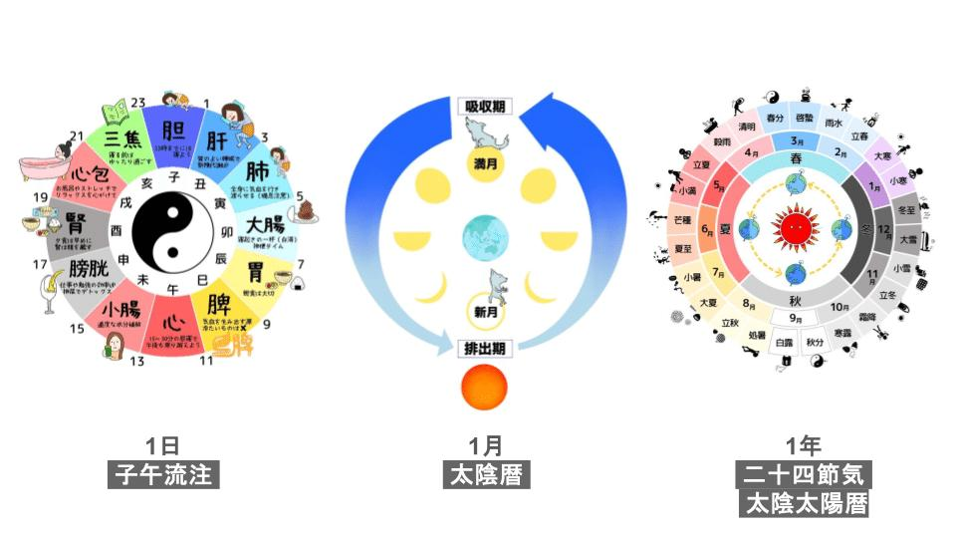
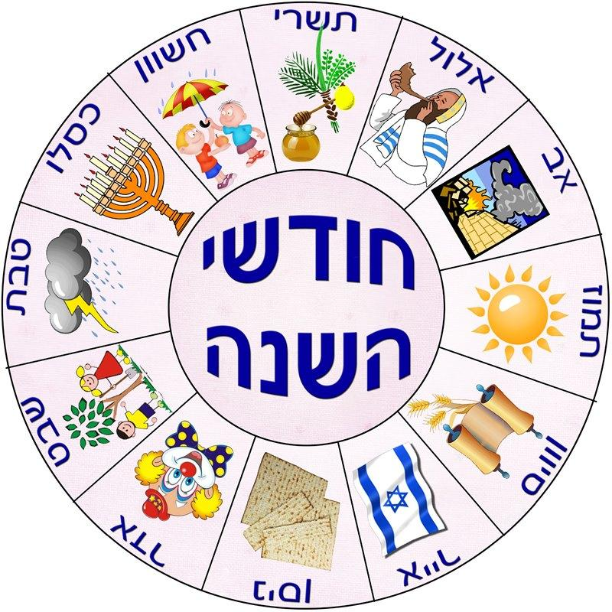
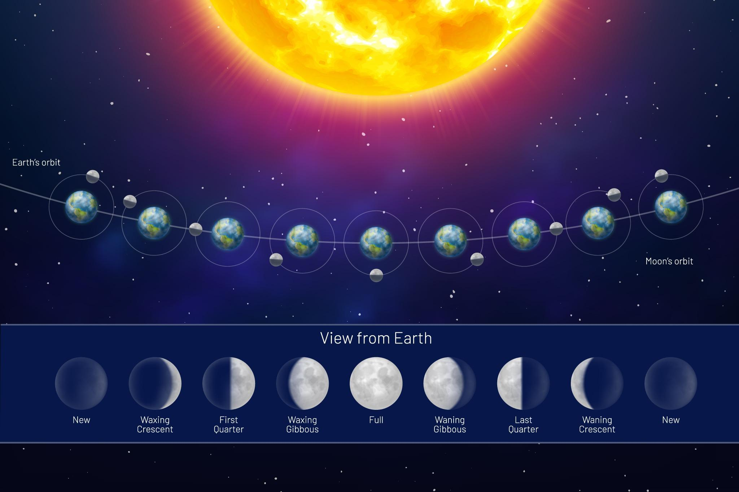
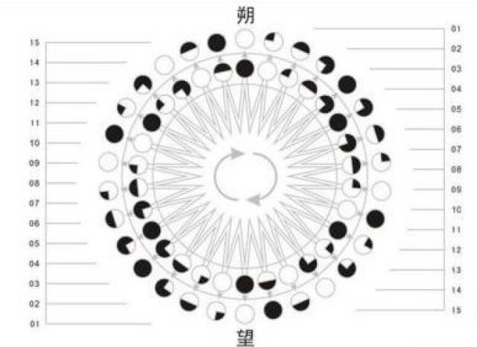
A Lunisolar Year is a year based on both the Moon's phases and the Earth's revolution around the Sun. It combines lunar months with periodic leap months so that the calendar remains synchronized with the seasons.
Unlike a purely lunar year, which gradually shifts through the seasons, a lunisolar year stays closely aligned with the solar year by occasionally adding an extra month.

Definition
# Source: AI Source: Provided by: [Data Path: Persons Table -> ID Column: 1, Name_En Column: Motasem Essam] -> From: [ChatGPT] on [7/17/2026]
A Lunisolar Year is a year composed of lunar months that is periodically adjusted with an additional (leap) month to keep the calendar aligned with the solar year and the seasons.

Astronomical Basis
# Source: AI Source: Provided by: [Data Path: Persons Table -> ID Column: 1, Name_En Column: Motasem Essam] -> From: [ChatGPT] on [7/17/2026]
A lunisolar calendar combines two astronomical cycles:
- The Moon's phases, which determine the months.
- The Earth's orbit around the Sun, which determines the seasons.
The goal is to preserve:
- Lunar months
- Seasonal consistency

Why Is Adjustment Needed?
# Source: AI Source: Provided by: [Data Path: Persons Table -> ID Column: 1, Name_En Column: Motasem Essam] -> From: [ChatGPT] on [7/17/2026]
One lunar year contains:
$$12×29.5306≈354.37\text{ days}$$
One tropical (solar) year contains:
$$365.2422\text{ days}$$
Difference:
$$365.2422-354.37≈10.87\text{ days}$$
Without adjustment, the calendar would move earlier by about 11 days every year, eventually becoming out of sync with the seasons.

Leap Month
# Source: AI Source: Provided by: [Data Path: Persons Table -> ID Column: 1, Name_En Column: Motasem Essam] -> From: [ChatGPT] on [7/17/2026]
Instead of adding a single leap day, lunisolar calendars usually add an entire leap month.
This extra month:
- Is inserted every 2 or 3 years (depending on the calendar rules).
- Keeps festivals and agricultural seasons aligned.
A common long-term pattern is:
- 7 leap months every 19 years
This is known as the Metonic Cycle.

Structure of a Lunisolar Year
# Source: AI Source: Provided by: [Data Path: Persons Table -> ID Column: 1, Name_En Column: Motasem Essam] -> From: [ChatGPT] on [7/17/2026]
A normal lunisolar year contains:
- 12 lunar months
- Approximately 354 days
A leap lunisolar year contains:
- 13 lunar months
- Approximately 383–385 days

Average Length
# Source: AI Source: Provided by: [Data Path: Persons Table -> ID Column: 1, Name_En Column: Motasem Essam] -> From: [ChatGPT] on [7/17/2026]
Over many years, the average length of a lunisolar year closely matches the tropical year:
$$365.24\text{ days (approximately)}$$

Calendar Systems That Use Lunisolar Years
# Source: AI Source: Provided by: [Data Path: Persons Table -> ID Column: 1, Name_En Column: Motasem Essam] -> From: [ChatGPT] on [7/17/2026]
Chinese Calendar
Used for:
- Chinese New Year
- Mid-Autumn Festival
- Traditional festivals
Features:
- 12 or 13 lunar months
- Leap month added when necessary

Hebrew Calendar
# Source: AI Source: Provided by: [Data Path: Persons Table -> ID Column: 1, Name_En Column: Motasem Essam] -> From: [ChatGPT] on [7/17/2026]
Used for:
- Jewish religious observances
- Passover
- Rosh Hashanah
- Yom Kippur
Features:
- 12 or 13 months
- Leap month added in specific years

Traditional Hindu Calendars
# Source: AI Source: Provided by: [Data Path: Persons Table -> ID Column: 1, Name_En Column: Motasem Essam] -> From: [ChatGPT] on [7/17/2026]
Many traditional Hindu calendars are lunisolar.
Used for:
- Diwali
- Holi
- Navratri
- Other religious festivals

Relationship to Other Types of Years
# Source: AI Source: Provided by: [Data Path: Persons Table -> ID Column: 1, Name_En Column: Motasem Essam] -> From: [ChatGPT] on [7/17/2026]
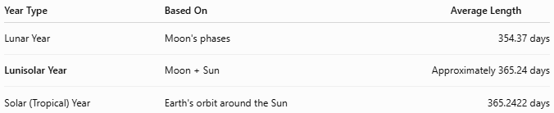
Year Type | Based On | Average Length
Lunar Year | Moon's phases | 354.37 days
Lunisolar Year | Moon + Sun | Approximately 365.24 days
Solar (Tropical) Year | Earth's orbit around the Sun | 365.2422 days

Applications
# Source: AI Source: Provided by: [Data Path: Persons Table -> ID Column: 1, Name_En Column: Motasem Essam] -> From: [ChatGPT] on [7/17/2026]
Lunisolar years are used in:
- Religious calendars
- Traditional festivals
- Agriculture
- Cultural celebrations
- Historical records

Advantages
# Source: AI Source: Provided by: [Data Path: Persons Table -> ID Column: 1, Name_En Column: Motasem Essam] -> From: [ChatGPT] on [7/17/2026]
A lunisolar year:
- Preserves lunar months.
- Keeps the calendar aligned with the seasons.
- Maintains consistency for agricultural and religious events.
- Balances both lunar and solar cycles.

Limitations
# Source: AI Source: Provided by: [Data Path: Persons Table -> ID Column: 1, Name_En Column: Motasem Essam] -> From: [ChatGPT] on [7/17/2026]
Lunisolar calendars:
- Are more complex than purely solar calendars.
- Require special leap-month rules.
- Differ between cultures in how leap months are inserted.

Common Mistakes
# Source: AI Source: Provided by: [Data Path: Persons Table -> ID Column: 1, Name_En Column: Motasem Essam] -> From: [ChatGPT] on [7/17/2026]
- Confusing a lunisolar year with a lunar year.
- Assuming leap years always add a day (lunisolar calendars usually add a month).
- Believing all cultures use the same leap-month rules.

Comparison of Year Types
# Source: AI Source: Provided by: [Data Path: Persons Table -> ID Column: 1, Name_En Column: Motasem Essam] -> From: [ChatGPT] on [7/17/2026]
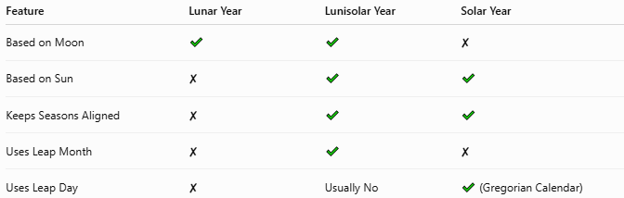
Feature | Lunar Year | Lunisolar Year | Solar Year
Based on Moon | ✔ | ✔ | ✘
Based on Sun | ✘ | ✔ | ✔
Keeps Seasons Aligned | ✘ | ✔ | ✔
Uses Leap Month | ✘ | ✔ | ✘
Uses Leap Day | ✘ | Usually No | ✔ (Gregorian Calendar)

Interesting Facts
# Source: AI Source: Provided by: [Data Path: Persons Table -> ID Column: 1, Name_En Column: Motasem Essam] -> From: [ChatGPT] on [7/17/2026]
- The Chinese, Hebrew, and many traditional Hindu calendars are lunisolar.
- The Metonic Cycle uses 19 years with 7 leap months to keep lunar months synchronized with the solar year.
- Lunisolar calendars have been used for thousands of years because they preserve both the Moon's phases and the seasonal cycle.

Key Points
# Source: AI Source: Provided by: [Data Path: Persons Table -> ID Column: 1, Name_En Column: Motasem Essam] -> From: [ChatGPT] on [7/17/2026]
- A Lunisolar Year combines:
  - Lunar months
  - Solar seasons
- It uses 12 or 13 lunar months.
- Leap months (not leap days) keep the calendar synchronized with the solar year.
- It is used in:
  - Chinese Calendar
  - Hebrew Calendar
  - Traditional Hindu Calendars
- Its average length closely matches the tropical year.

Conclusion
# Source: AI Source: Provided by: [Data Path: Persons Table -> ID Column: 1, Name_En Column: Motasem Essam] -> From: [ChatGPT] on [7/17/2026]
A Lunisolar Year is a timekeeping system that combines the Moon's monthly cycle with the Earth's yearly revolution around the Sun. By periodically adding an extra leap month, it maintains both the natural sequence of lunar phases and the regular occurrence of the seasons. This balance makes lunisolar calendars particularly valuable for religious traditions, cultural festivals, and agricultural planning, allowing them to preserve the benefits of both lunar and solar timekeeping.

